Study chapter 11. Download workbook “HW08”. The “Data Set” worksheet tabulates information about 263 patients who are to be scheduled for the Electrophysiology lab at the cardiology unit in a local hospital. The “Lists” worksheet includes a set of data elements to be used for developing combo boxes. The objective of this HW is to practice developing user forms; populating forms from data stored in worksheets as well as storing data in worksheets captured via the forms from a user. A side objective of this HW is practicing modularization; partitioning the development into a set of tasks. Each task is coded and tested independently. Next these procedures and functions are integrated to make the final solution.

1. Developing Forms.
   1. Name the ranges for the seven lists:   
        
        
        
      
   2. Insert a user form and name it. Also, place a title in its caption.
   3. Place a user form, as shown in the picture. It includes a set of textboxes, labels, combo boxes and a checkbox.   
        
        
        
        
        
        
        
        
        
        
        
        
        
        
        
        
        
        
        
        
       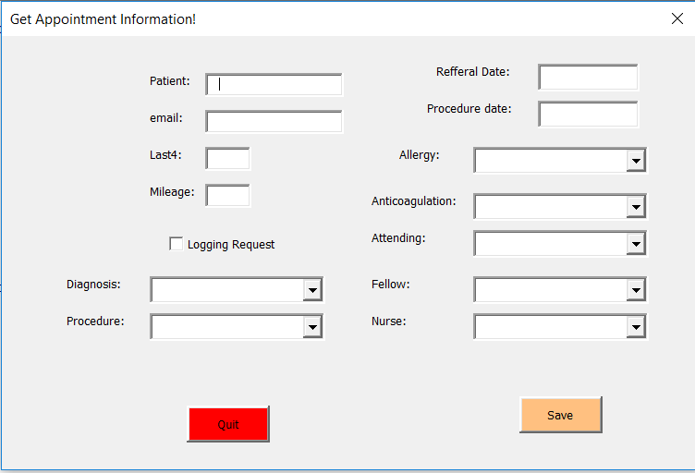
   4. Place two command buttons, one to save the captured data into the “Data Set” worksheet and one to quite.
   5. Name all controls; only the ones that you will use in your code. Format the form to your satisfaction. [Hint: use conventional names for your controls so they can be easily found with intellisense]
   6. Develop a procedure that when it is called, it *shows* your form. Place a button on the “main” worksheet to run this procedure.
   7. Add code in the User Form so that it populates the seven combo boxes. [Hint: the code is added in the Initialize Event Handler]
   8. Develop a function in the User Form that when is called, it resets the form. Hint: all ListIndex properties are set to “-1” and all textboxes are set to blank, and checkbox is set to *False*. Call this function from the Initialize Event Handler.
   9. Add code to the Save command button so that when it is clicked, the content of the form will be written into the spreadsheet. The “Data Set” worksheet is empty to start. After the captured data is recorded, call the “reset” function to reset the form. Assign case IDs sequentially, starting with one.
   10. Add code to the Quit command button so that when it is clicked, it terminates the program.